1：Create a new folder in the root directory of the USB drive and rename it to "UPG_ALL" in all capital letters.
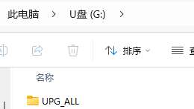

2: Place the decompressed “8563_linux_demo_dbg.bin” and “mt8563_bl_linux.bin” files into the UPG_ALL folder. Please note that the file names should not be changed arbitrarily.

3: Insert the USB drive into the BD player and make sure the BD player has recognized the USB drive. This is to prevent the inability to locate the upgrade file during the upgrade process due to the failure to recognize the USB drive.

4：Click on "Setting" on the desktop to enter the UI menu.
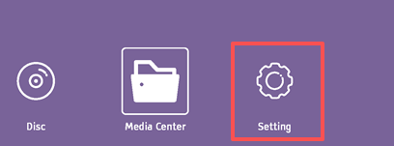

5：Select the options in the menu one by one, System—>UpgradeUSB Storage
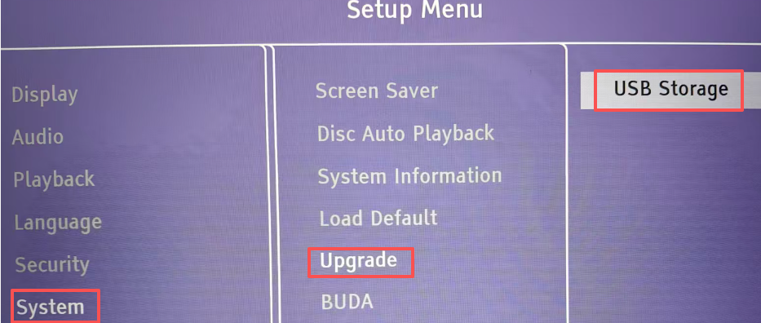

6: Press the "OK" button on the remote control. The BD player will automatically upgrade. The machine will automatically restart if it finished upgrade. Please MUST connect the power adapter during upgrade firmware period.

